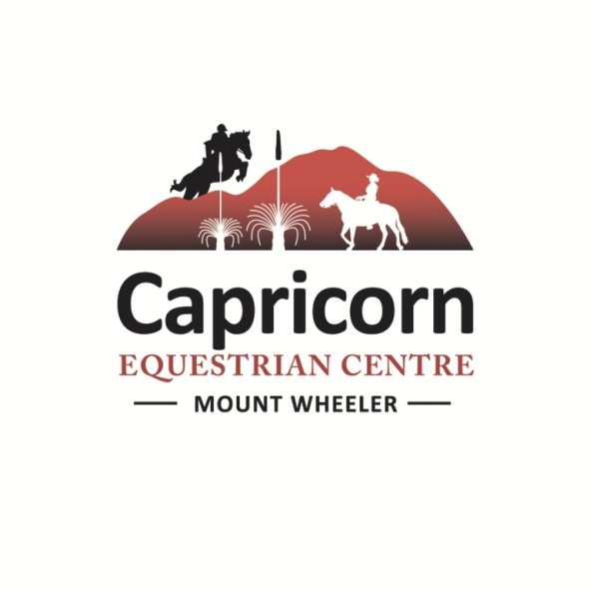

Sand Dance Equestrian Clinic

Saturday 11h and Sunday 12th April 2026

Felicity Mitchell provides an inclusive and encouraging environment. This clinic will help boost your horsemanship, confidence and partnership in the stunning environment of Capricorn Equestrian Centre on it’s large sand arena with stunning the backdrop of Gai-i.

Felicity is a Cowboy Dressage felicitator and will blend these skills into the clinic to help you find a better partnership, timing, soft feel and balance with your horse. This clinic will suit riders looking to have fun and build confidence, and improve their relationship with their horse.

VENUE:
Capricorn Equestrian Centre
291 Mount Wheeler Road, Via Mackays Road, Yeppoon-Rockhampton road,
Yeppoon.
Please note if you are using a GPS, do not attempt to bring a horse float via Cawarral, this is a 4WD track not suitable for towing trailers.
Best directions; https://www.capricornequestrian.com.au/directions. We have two entries heading over to our arena, The first entry is Capricorn Equestrian Centre – yards and camping (hot showers area), The Barn entrance is for the arenas only – bush camping and electric fencing is welcome in this area as well. It is also an easier entrance for goosenecks and long vehicles.

For day visitors it is best to park at the arena.

You are welcome to bring your own food and drinks, although ticket price for riders and fence sitters does include morning and afternoon tea, and lunch, which will be sandwiches and salad. If you have special food needs please advise, vegetarian and gluten free are not a problem as lunch is a selection of salads, cheese and meat for you to make your own choices. Tea, coffee and drinking water will be available all day.

Come along to very scenic Capricorn Equestrian Centre and enjoy our facilities whilst learning from a Cowboy Dressage expert. Set on 500 acres with a 60 x 60 m fenced sand arena and second dressage arena there is plenty of riding space, covered viewing gallery and we will provide morning / afternoon tea and lunch for each day, byo a comfy chair for fence sitting with a notepad and pen to help remember for later.
Clinic Times 11th and 12th April :

Saturday will be a 8.30am start finishing around 5pm, Sunday will be 8.30am start finishing around 4pm.

Groups will be organised and sent out before the day.

Please arrive early on your first day to sign in, organise collection of the paperwork, and so we can organise the riders into the suitable groups and have the first group ready on the arena for an 8.30am start. Saddled and ready to ride. Capricorn Equestrian Staff will be available from 8am.

I will organise you into groups......this is not set in stone, and is subject to change as Felicity sees fit. On Sunday if you would like to be group 2 in the afternoon to get a quick getaway for a long drive home please just let us know.

Group 1 | Group 2

Accommodation:
- Overnight yards, $10 per horse/per night, situated near bunk house.
- Camping free to clinic riders otherwise $10 p/night basic bush camping, hot showers on site, available 10th April – 12th April
- Camping can either be next to horse yards.
There is no 240 power onsite sorry as we are off grid, you are welcome to bring generators. You will also need to bring your own esky – Let me know if you need a helping hand with ice as we can freeze up some water bottles for you we also have a large esky in our shed.
- Bunk house accommodation available $25 p/p/night. Available Friday 10th April – 12th April. Includes bedding, you need to bring towels, breakfast and dinner and milk, the bunk house has bbq cooking facilities, plates and cutlery, tea and coffee. There is also a small fridge for you to use.

Paperwork checklist, Please fill out this form at
https://form.jotform.com/260081860078861
and an invoice will be sent out to you – a place in the clinic is only secured by a payment.
Ther will be other forms to bring along on the day or return via email.
- Biosecurity Horse Health declaration form.
- A completed Capricorn Equestrian Centre waiver form
- For your records our PIC number is attached to the horse health declaration form and is : QKLI0789
- We require you to sign in each day.

Please do not hesitate to contact Madeline if you have any other queries or concerns,
with kind regards,

Madeline and Glen

Contact: Madeline Chery Mobile: 0413 483 850

Glen Bridgeman Mobile: 0427 392 610
Email : cctrailrides@bigpond.com
Evenings 07 4939 2611
www.capricornequestrian.com.au

