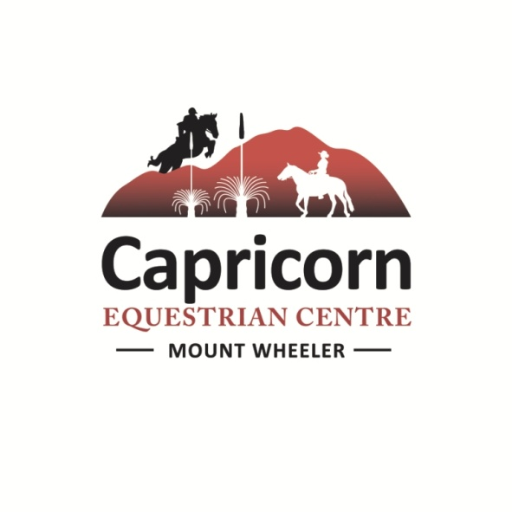

**ANGIE WICKS Clinic**

Friday 30th May Saturday 31st May and Sunday 1st June 2025

Angie has a strong attention to detail and regardless of your discipline followed you will find improvement in your position and riding ability.

Angie is also an expert ground worker with horses too and has much to offer with ground work techniques as well.

**VENUE:**

Capricorn Equestrian Centre

291 Mount Wheeler Road, **Via Mackays Road**, Yeppoon-Rockhampton road,

Yeppoon.

*Please note if you are using a GPS, do not attempt to bring a horse float via Cawarral, this is a 4WD track not suitable for towing trailers.*

A mud map is attached to this email. We have two entries heading over to our arena, our second entry now has a double gate, which will allow goosenecks more room to swing in through the gate.

For day visitors it is best to park at the arena.

**You are welcome to bring your own food and drinks,** although ticket price does include morning and afternoon tea, and lunch, which will be sandwiches, bbq and salad. If you have special food needs please advise, vegetarian and gluten free are not a problem. Tea, coffee and drinking water will be available all day.

**Friday 31st May 2025 the Ground Up Clinic**

Ground work with Angie

Start time:

|  |  |
| --- | --- |
| **Friday** |  |
| **Group 1** | **8-10 am** |
| Group 2 | 10-12 pm |
| **Lunch 12 – 1 pm** | |
| **Group 1** | **1-3 pm** |
| Group 2 | 3-5 pm |

|  |  |
| --- | --- |
| **Group 1** | **Group 2** |
|  |  |
|  |  |
|  |  |
|  |  |
|  |  |
|  |  |
|  |  |
|  |  |

What you need to bring:

Equipment. This is ideally – if you don’t have the exact equipment, we can share between riders.

- a rope halter

- a 12 or 14 foot good quality as possible lead rope (not Dressage style lunge ropes or not short flimsy 8-10 ft lead ropes) If people have 22 foot ropes they can bring those too

- a lead rope with a silver/brass clip. If the lead rope attaches to the halter directly, no clip. That is ok if the horse is very soft and responsive BUT if the horse is pushy and dull you will need a good quality lead rope with a clip on it so it's weighted.

- sticks. Ideally firm and shortest sticks. Any kind of carrot stick and string. (Angie likes to use Parelli or Downunder Horsemanship KIDS stick. As they are shorter, lighter, but firm and good quality.) People can make a stick and string too. ( Dressage lunge sticks are too long, bend and hard to use although they are better than nothing.) There is sometimes enough equipment to share, contact Madeline if you are not exactly sure what you may need.

Come along to very scenic Capricorn Equestrian Centre and enjoy our facilities whilst learning from a master. Set on 500 acres with a 60 x 60 m fenced sand arena and second dressage arena there is plenty of riding space, covered viewing gallery and we will provide morning / afternoon tea and lunch for each day, byo a comfy chair for fence sitting with a notepad and pen to help remember for later.

**Clinic Times 31st May and 1st June** :

Angie organises her clinic by dividing the participants into two groups.  Each group has 2 hours in the morning and 2 hours in the afternoon and will fence sit the other group.  The times will be:

|  |  |  |  |
| --- | --- | --- | --- |
| **Saturday** |  | **Sunday** |  |
| **Group 1** | **8-10 am** | Group 2 | 8-10 am |
| Group 2 | 10-12 pm | **Group 1** | **10-12 pm** |
| **LUNCH – 12-1pm** | | | |
| **Group 1** | **1-3 pm** | Group 2 | 1-2.30 pm |
| Group 2 | 3-5 pm | **Group 1** | **2.30 – 4 pm** |

Please arrive early on your first day to sign in, organise collection of the paperwork, and so we can organise the riders into the suitable groups and have the first group ready on the arena for an 8 am start. Saddled and ready to ride. Capricorn Equestrian Staff will be available from 7am.

I will organise you into two groups......this is not set in stone, and is subject to change as Angie sees fit. On Sunday if you would like to be group 2 in the afternoon to get a quick getaway for a long drive home please just let us know.

|  |  |
| --- | --- |
| **Group 1** | **Group 2** |
|  |  |
|  |  |
|  |  |
|  |  |
|  |  |
|  |  |
|  |  |
|  |  |

**Accommodation:**

* Overnight yards, $10 per horse/per night, situated near bunk house.
* Camping free to clinic riders otherwise $10 p/night basic bush camping, hot showers on site, available 31st May – 2nd June
* Camping can either be next to horse yards or over at the arena – horses can be penned in byo electric fencing if you would like to stay over at the arena.

There is no 240 power onsite sorry as we are off grid, you are welcome to bring generators. You will also need to bring your own esky – Let me know if you need a helping hand with ice as we can freeze up some water bottles for you 😊 we also have a large esky in our shed.

* Bunk house accommodation available $25 p/p/night. Available Thursday 29th May– 2nd June. Includes bedding, you need to bring towels, breakfast and dinner and milk, the bunk house has bbq cooking facilities, plates and cutlery, tea and coffee.

**Paperwork checklist,** these forms are attached to this email (or will be sent upon you booking a place) and must be completed and brought along on the first day or returned to us via email.

* Biosecurity Horse Health declaration form.
* A completed Angie Wicks waiver form
* For your records our PIC number is attached to the horse health declaration form and is : **QKLI0789**
* We require you to sign in each day, as Angie will keep your waiver forms.
* If you are sick with a cold, temperatures or flu type symptoms please remain at home and follow current COVID guidelines.

Please do not hesitate to contact Madeline if you have any other queries or concerns,

with kind regards,

Madeline and Glen

**Contact: Madeline Chery Mobile:** 0413 483 850

Glen Bridgeman Mobile: 0427 392 610

**Email** : [cctrailrides@bigpond.com](mailto:cctrailrides@bigpond.com)

**Evenings** 07 4939 2611

[www.capricornequestrian.com.au](http://www.capricornequestrian.com.au)